Instructions for preparing manuscript for International Physics Conference (IPC) ← 14 TNR Bold Italic 14 Words

Rizki Zakwandi  r.zakwandi@upi.edu  Physics Education Study Program, Universitas Pendidikan Indonesia, Bandung, Indonesia | Author 2:  Email Author 2:  Affiliation Author 2.
Author 3:  Email Author 3:  Affiliation Author 1. | Author 4 :  Email Author 4:  Affiliation Author 4.
Author 5 :  Email Author 5:  Affiliation Author 5. | Author 6 :  Email Author 6:  Affiliation Author 6.
This article was presented at the National Physics Seminar (3rd )
Universitas Pendidikan Indonesia, Bandung, Indonesia
16 Juni 2026

Abstract
Abstract English version, written using Time New Roman-10.5, italic. Abstract contains research aim/purpose, method, and reseach results; written in 1 paragraph, single space among rows, using past tense sentences.

Keywords: Keyword 1 · Keyword 2 · Keyword 3 · Keyword 4 · Keyword 5

INTRODUCTION (10%)
Contains the background, rationale, and/or urgency of the research. References (relevant literature or previous studies) must be included in this section to justify the urgency of the research, highlight the research problem, present alternative solutions, and specify the chosen solution. In-text citations must clearly indicate the author's name and the source details, specifically the publication year and the page number where the text is located. For example: "... research findings indicate that more than 70% of students are unable to recognize authentic problems... (Retnawati, 2014)."
The currency of the cited materials should be maintained, prioritizing primary sources published within the last 10 years. The research problems, objectives, and significance should be written narratively within paragraphs without using specific subheadings. Similarly, operational definitions, if deemed necessary, should also be written in a narrative format.
The introduction is written in upright Times New Roman, font size 11, with single spacing. The first line of each paragraph should be indented by 5 digits, or approximately 1 cm from the left margin of each column.

METHOD (15%) (Heading 1, Myriad Pro Cond, 13pt, bold, capslock)
Contains the research design, time and location of the study, targets, research subjects, procedures, instruments, data analysis techniques, and other matters related to the research methodology. The targets, research subjects, procedures, data and instruments, data collection techniques, data analysis techniques, and other related methodological elements may be written in subsections using sub-subheadings. These sub-subheadings do not need to be numbered or lettered; instead, they should be written in left-aligned, unbolded Times New Roman 11-point font, using sentence case (lowercase with an initial capital letter).
Particularly for qualitative research, the time and location of the study must be clearly stated (this is also required for quantitative research). The research targets/subjects (for qualitative research) or the population and sample (for quantitative research) need to be clearly detailed in this section. The strategy for selecting subjects (qualitative research) and/or the sampling technique (quantitative research) must also be specified.
Procedures should be described according to the specific type of research. This section must outline how the study was conducted and how the data will be obtained. For experimental research, the specific experimental design used should be stated here. The types of data, how the data were collected, which instruments were used, and the technical procedures for data collection must be clearly detailed in this section.
How the obtained data are interpreted in relation to the research problems and objectives must be clearly explained.
(Note: Subsections may vary depending on the type or approach of the research used. If there are procedures or steps that are sequential in nature, they may be numbered or lettered according to their order).
rESULTs AND DISCUSSION (70%) (Heading 1, Myriad Pro Cond, 13pt, bold, capslock)
Research findings are presented in the form of graphs, tables, or descriptive text. The analysis and interpretation of these results are required before they are discussed.
Result (Heading 2, Myriad Pro Cond, 12pt, Bold)
Tables are placed either in the middle or at the end of the text describing the research results/findings. If a table is too wide to fit within a single-column width (half-page), it may span across the full width of the page. The table title should be left-aligned but centered relative to the table itself, with all words capitalized except for conjunctions (title case). If the title exceeds one line, it must be single-spaced. For example, see Table 1.
Tabel 1. The Style and Its Function ← 11 pt
No. | Name of Style | Function
1. | IPC_Title (11 PT) | Title
2. | IPC_Author | Author
3. | IPC_AbstractBody | Abstract
4. | IPC_AbstractTitle | Abstract Title
5. | IPC_AbstractKeyword | Keyword
6. | IPC_Heading 1 | Subtitle 1
7. | IPC_Body | Paragraph
8. | IPC_Picture Capture | Figure Title
9. | IPC_Table Capture | Table Title
10. | IPC_Reference | List of References
 | And more
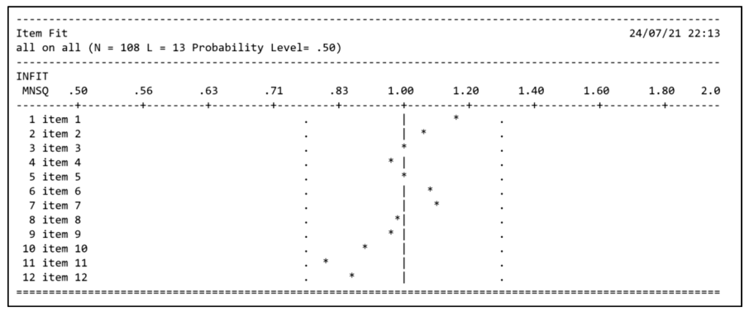
Gambar 1. Applying Styles in the Template
Results in the form of figures—including data presented as images, schemes, graphs, diagrams, or the like—must also follow the established rules: the figure title or caption is placed below the figure, left-aligned, and spaced 1 single line below the image. If the caption exceeds one line, it must be single-spaced. For example, see Figure 1.
Equation (Heading 3, Myriad Pro Cond, 12pt)
The writing example in IPC. Use Mathtype or microsoft equation 3.0.
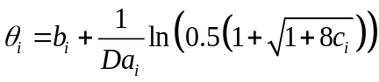 (1)
Conclusions (5%)
Conclusions may consist of a generalization of the findings in accordance with the research problems, or they may take the form of recommendations for future steps.
ACKNOWLEDGMENTs (IF AVAILABLE)
Write your acknowledgements here.
references
Articles are expected to use a minimum of approximately 25 recent primary references. The formatting of in-text citations and the reference list must strictly adhere to the APA (American Psychological Association) Style. To maintain consistency in referencing and citation, authors are highly encouraged to use reference management software, such as Zotero, Mendeley, or other premium applications. The reference list should be single-spaced, with a single-line space separating each entry.

